WEEK 5

- A data automation team is creating a utility module that performs multiple independent calculations based on user inputs. Write a Python program that accepts required inputs from the user and defines separate functions to perform:
  - Find the largest of three numbers (positional arguments).
  - Compute the volume based on user’s chosen shape: – cylinder (r, h), cube (a), or rectangular box (l, w, h).
  - Compute the area of a rectangle.
  - Compute the circumference of a circle.
  - Exchange the values of two variables.
  - Find the distance between two points (x1, y1) and (x2, y2) using math.dist(). (Use switch case to execute the required function)
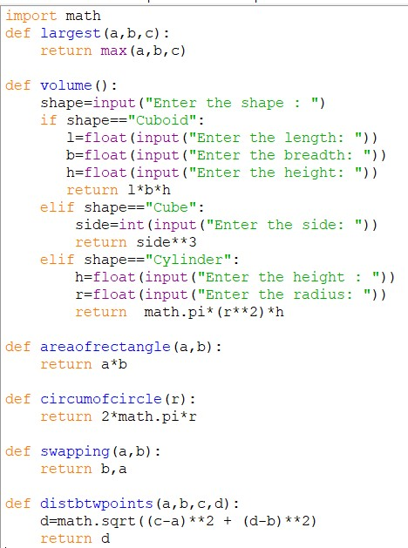
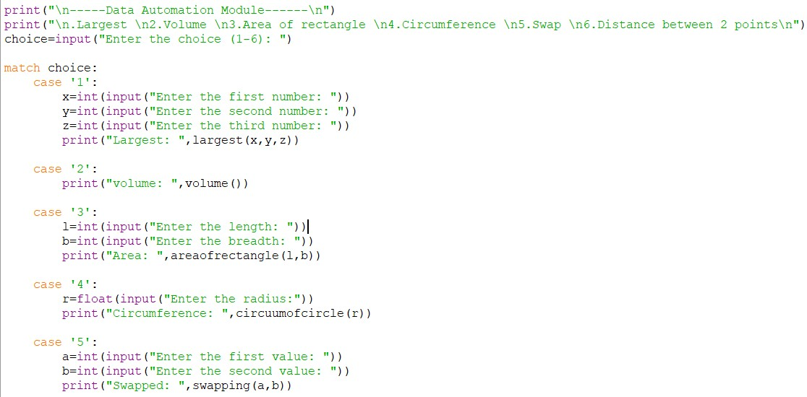

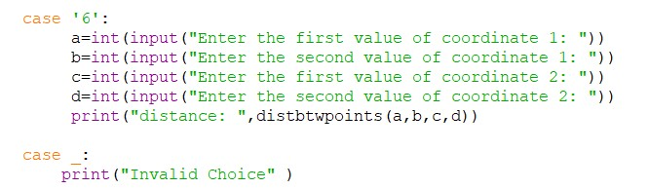
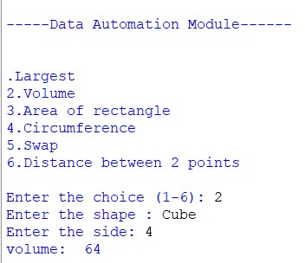
- A billing system receives an unknown count of numeric entries per invoice. Write a Python function that accepts arbitrary integers and returns their sum. (Hint: use *args)

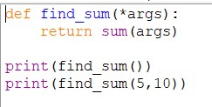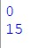

- A text-filtering tool needs to remove noisy characters occurring at odd positions. Write a Python program that takes a string and removes all characters at even index values. Example 1: • Input: "H@e#l$l" • Output: "el"

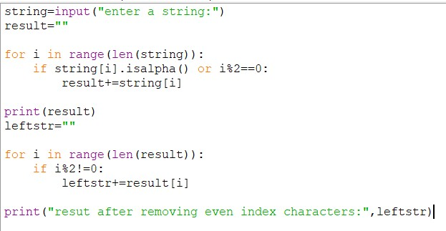

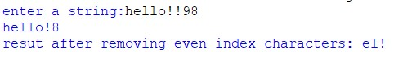
- Write a Python script that takes input from the user and displays that input back in upper and lower cases.

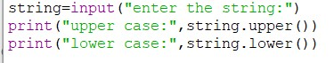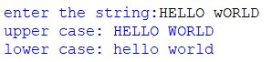

- A simple analytics module must calculate keyword frequency in user feedback. Write a Python program to count occurrences of each word in a sentence.
Example 1: • Input: "Hello hello world" • Output: {'hello': 2, 'world': 1}

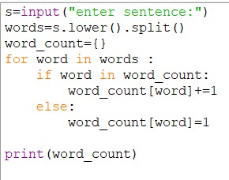
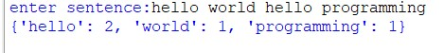
- A document cleanup tool needs to normalize text copied from notes. Write a Python program to remove indentation from each line of a multi-line text.

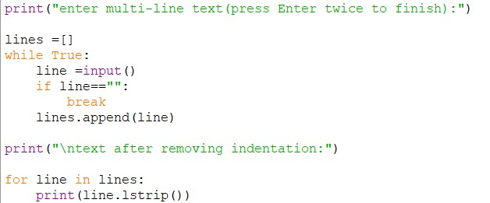

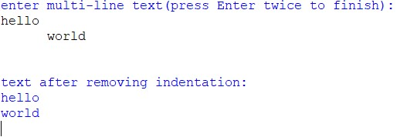
- Write a function that reverses a string. The input string is given as an array of characters s. You must do this by modifying the input array in place with O(1) extra memory.

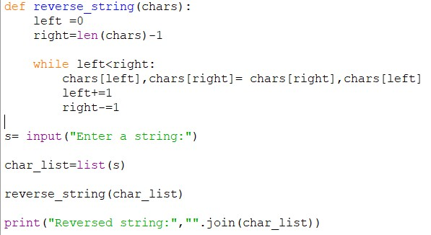

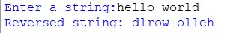

- Given a string s, reverse the order of characters in each word within a sentence while still preserving whitespace and initial word order.

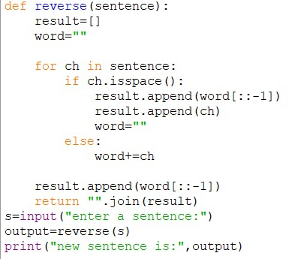
- A parser converts messages into list-based tokens. Write a Python program to convert a string into a list of characters.
Example 1: • Input: "Hi 5" • Output: ['H','i',' ','5']

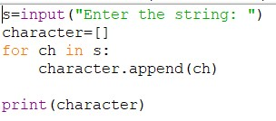

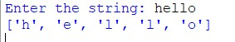

- Write a Python program to count and display all vowels present in the text. Also display consonants and its count.

